**Whiskeroscope: rodent whisker inspired sensor for use in analysis of plant tissue structure**

**1. Summary:**

Understanding mechanical properties of plant biomass is crucial for multiple industries, including building construction and production of lignocellulosic biofuels. Current methods to analyse mechanical properties of biomass are slow and provide little accuracy. The aim of the project was to develop a prototype of a novel type of mechanical sensor which addresses challenges outlined above. The device is inspired by rodent whiskers and relies on two inputs, obtained using thin steel rod, to quantify stiffness. During each measurement the primary, macromotion, dataset is obtained by analysing the extent to which the whisker bend during the contact with the material. Additional information is obtained by overlaying the macromotion data with the impact of the whisker contacting the material on its micro-oscillation. The instrument successfully discriminated between materials with unlike mechanical properties (steel and foam) and differently aged stem samples from willow. Whiskeroscope was also applied to study *Arabidopsis thaliana* stems with altered composition of secondary cell walls. The project and the background information on plant cell walls were demonstrated to the wider public as a part of the Open Plant’s contribution to the Cambridge University Science Festival.

**2. Hardware design:**

We implemented a sensor system with a single artificial whisker; with motion and sensing capabilities that are functionally comparable to a natural rat whisker system. The artificial whisker is a thin, elongated, hair-shaped flexible steel wire (referred to as e-whisker from here) with two small disc shaped magnets attached at its base. Two magnetic flux sensors are located below the magnets and can measure the changes in the magnetic flux caused by the movement of the disc shaped magnets (Figure 1A). The e-whisker along with the base sensors is provided with a rotational mechanism which is driven by a large motor which allows the e-whisker to rotate slowly to come in contact with the material being sensed (Figure 1B). Additionally, the flexible e-whisker can rotate back and forth around its rotational axis by small angles at a high frequency (25 Hz to 80 Hz) (Figure 1A). The e-whisker deforms its shape on contact with plant tissue. This deformation of the whisker causes fluctuating voltage signals to be generated at the base sensors. These voltage signals are recorded by a Data Acquisition Card connected to a PC (Figure 2). The voltage signals encode the sensory information related to the contact of the whiskers with the tissue. The voltage signals are relayed to a processing unit where they are decoded to extract relevant tactile information.



Figure 1. **A)** Components of the whiskeroscope detection module. Upon contact with the sample the e-whisker (a) deflects from its initial position what leads to change in position of the magnets (b). Micro-motor (c) allowed for the whisker to be oscillated at set frequency during some experiments. **B)** NEMA17 step-motor was used to move the e-whisker and parts of the detection mechanism during the sample analysis.



Figure 2. Outline of the whiskeroscope. Single computer can be used to run the device. Large scale movements of the device can be controlled using Arduino (a) connected to NEMA17 step-motor via a driver (b). Micro-oscillation of the e-whisker is introduced and controlled using specific chip (c) which is dscribed in more detail in appendix A. All data generated from both macromotion and micro-oscillation are read by the National Instruments NI USB-6210 data acquisition card (d). Samples are mounted onto a holder using tape which is cut to allow for interaction between the e-whisker and the analysed material (e).

**3. Software design:**

In order to analyse samples using the whiskeroscope the e-whisker needs to be in contact with the analysed material. This process is achieved using step-motor controlled via an Arduino. Position of detectors fixed onto the e-whisker is recorded and logged using a NI Data Acquisition Card controlled using a LabView script supplemented with a GUI. Micro-motor movement is controlled using Arduino operated chip. Data analysis is performed using a set of Matlab scripts.

3.1 Arduino based control of the NEMA17 step-motor.

The large motor for macro-motion of the e-whisker is controlled by an ‘EasyDriver’ board (Figure 3) connected to an “Arduino Uno”. The ‘EasyDriver 4.4’ along with its complete pin information is available on its official website <http://www.schmalzhaus.com/EasyDriver/> . The Arduino sketch used for the “Whiskeroscope” project involved a modified Arduino sketch which made the whisker swing back and forth at a pre-defined speed.

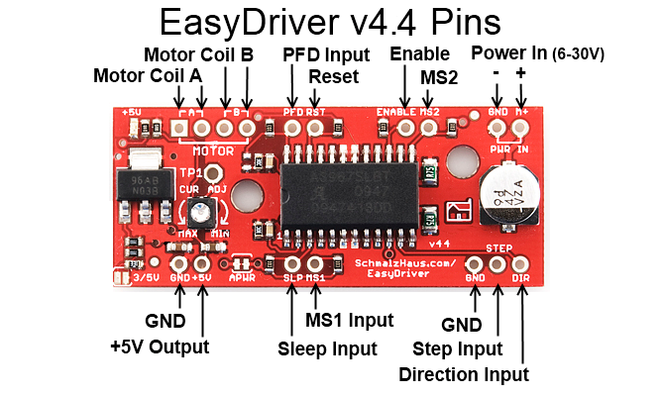

Figure 3. Overview of the EasyDriver v4.4 board used to control the NEMA-17 motor.

3.2 LabView tool for the interaction with the Data Acquisition Card.

A graphical user interface that displays and records the real time values of the sensors that are being read by the Data Acquisition Card (DAQ) (Figure 4)

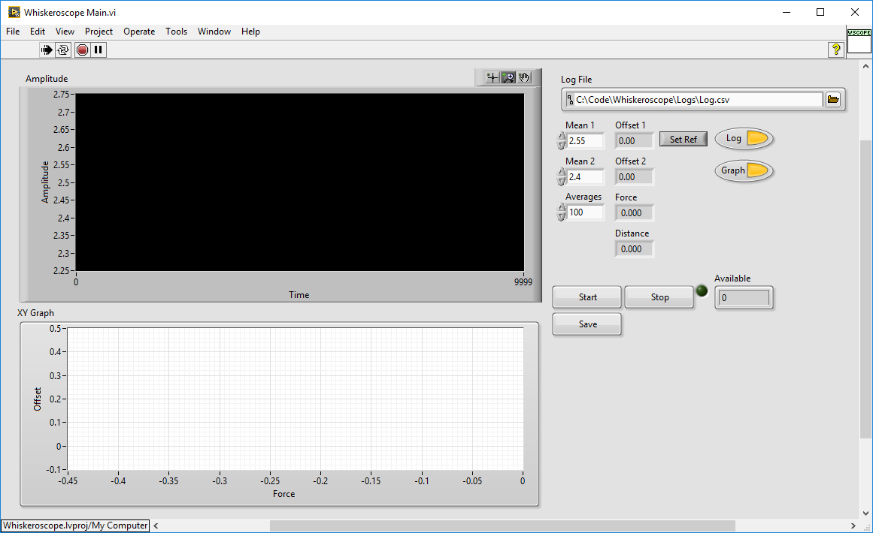

Figure 4. GUI used for the interaction with the NI Data Acquisition Card.

The GUI is a crude LabView tool that interfaces with the NI DAQ device and records data from the two hall sensors coupled with the whisker magnets. When the software is executed, the “Start” button will start data collection. If “Log” is enabled, data will be logged to memory. If “Graph” is enabled, the data will be displayed. The “Set Ref” button will use the current sensor values is zero reference and should be used when micromotion is off and the whisker is still. The “Offset” values should go to 0.00. The “Force” and “Distance” values will update realtime. Currently they are uncalibrated. Calibration would require setting the “E” and “I” constants as per the beam equation. The XY graph shows force against one of the sensor values, which is useful for gauging stiffness and hysteresis. The number of “Averages” increases the signal quality and reduces the effective logging frequency. To save the logged data to file, remember to press “Save” after logging. The log file will be overwritten. Log buffers will be cleared when pressing “Start” or setting “Log” to ON. For future development, we suggest that built in Labview DAQ functions are used to log the data straight to file and processed afterwards

3.3 Arduino based driver for the micro-motor

The micro-motor Arduino software controls the motion of a small actuator by generating sinusoidal signals at either fixed frequency or performing a frequency sweep. A quarter sinusoid is generated and stored in memory. This reduces processing overhead, thus allowing higher frequencies, while requiring little memory. A Timer 2 compare interrupt adjusts the duty cycle of a PWM peripheral according to the next sinusoid point. The PWM peripheral drives the high frequency signal onto pin D9 and inverted onto pin D10, which drives the positive and negative pins of the L293 H-driver chip. This effectively allows analogue control of the electromagnetic actuator. The sinusoid length, timer clock, overflow settings and PWM frequency were tweaked to allow both good signal shape and frequency. Frequency was verified using a scope.

The protocol simply takes a character followed by one or more parameters and a line feed:

“F40” - Sets frequency to 40Hz.

“F0” - Turn off signal output.

“A50” - Sets amplitude to 50%.

“S40 3” - Sweep from current frequency to 40Hz at a rate 3t/Hz, where t is some fixed time.

Commands will respond with a message indicating the actual settings achieved.

3.4 Matlab scripts used for the data analysis

Post processing software written in Matlab analyses the recorded sensor data and converts it into a meaningful mechanical property.

a. The macro-motion processing involves finding the force applied to the e-whisker by the stem as the e-whisker presses against the stem. The force (starting from a zero force) is plotted against the number of motor steps (which correspond to increasing local deformation of the stem). Thus, the slope of the curve (force against deformation) gives us the relative stiffness values of the stem. In this manner a number of stems were compared.

b. The micro-motion processing was based on the hypothesis that materials of different stiffness damp high-frequency oscillations to different extents. The processing in this stage involved finding the peak to peak amplitude of the micro-motion signal as the e-whisker was pressed against the stem. The amount of damping in this signal was plotted against the macro-motor steps and gives us a measure of the relative stiffness of the stem.

**Data acquisition and analysis of plant material:**

We divided the project into two stages, where the first stage involved analysing the whisker deformation due to the contact with the plant stems only with macromotion. The basic model of the system is displayed on Figure 5A. All calculations of stem properties were based on the whisker deflection model (Kim and Moller, 2006) to calculate the force P applied by the stem on the whisker (Figure 5B).



Figure 5 A) Schematic of the experimental set-up used to acquire data using macromotion setting of the whiskeroscope. B) Whisker deflection model (adapted after Kim and Moller, 2006).

The system was used to analyse 8 stem samples from willow (*Salix* spp.) (Figure 6A). Data was gathered using macro-motion analysis only and analysed using Matlab scripts as described before. The device was able to differentiate between stem stifness values for samples 4 to 6 which are expected to have lowest mechanical resistance (Figure 6B). Samples 1-3 and 7 – 8 all displayed simillar stifness values what might have beed caused by too big difference between the stifness values of the e-whisker material and the plant stem analysed. However, as majority of further work was focused on analysing *Arabidopsis thaliana* stems, which are expected to have stifness simillar to samples 4 – 6, it was concluded that the set-up is suitable for further experimentation.



Figure 6. A) Willow samples analysed in one of the experiments. B) Analysis of force between whiskers over consecutive motor steps. With increasing deflection of the e-whisker stiffness differences between stem samples 4 to 6 can be distinguished.

The second stage involved using high frequency motion contact (‘micro-motion’) to analyse the relative stiffness of the *A. thaliana* stems. In this model, in addition to the above motor motion, the e-whisker was oscillated continuously at a fixed frequency of 70 Hz. The damping of the oscillation signal on contact with the stem was analysed for different stems. This seemed to correlate with the stiffness of the stems but further data analysis is required to completely understand the relationship between the oscillating signals and stem stiffness. The datasets are available openly and further analysis especially using neural network based learning algorithm will be able to predict the stem properties further. We plan on organising a ‘Machiine learning’ competition using those datasets.

**Challenges:**

The proposal included a third stage whereby multiple whiskers would be used. However, due to the time constraints we decided to skip the third stage and improve the second stage, which in fact gave us acceptable results. The proposal also included use of neural network type analysis on frequency response of the stem. However, this type of analysis was left as an after-project exercise due to time constraints. Hopefully, the additional time spent in building the system and collecting data for multiple sensors would be compensated by allowing this analysis to be completed on the open data.

**Public outreach:**

In order to familiarise the wider community with biomimetics and importance of plant biomass for our everyday lives we have displayed the Whiskeroscope at the Cambridge University Science Festival on 12/03/2016 (Figure 7). On the day we have demonstrated how the Whiskeroscope can be used to analyse the mechanical properties of plant biomass. We have highlighted that often in engineering the inspiration from the natural world might be the best solution to challenging technical problems. In addition to that we have attempted to explain how, on a molecular level, plant cell walls, forming a great majority of the biomass, might be structured. We have used this opportunity to outline that biomass properties could be changes to suit better the needs of industries such as construction or biofuel. Our presentation often led to discussion on the public’s acceptance of creating genetically modified plants. Majority of the visitors were positive about using genetic engineering to improve properties of plant material used as a biomass feedstock for biofuel production.

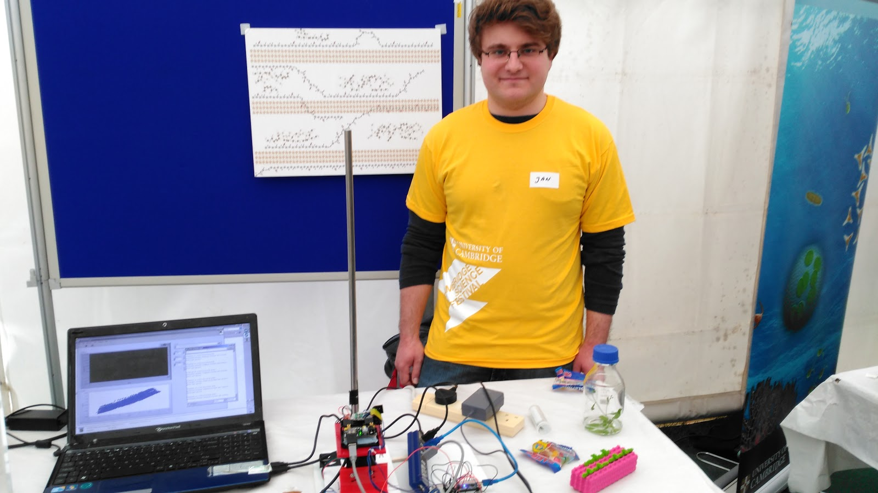

Figure 7. Whiskeroscope display at the Cambridge University Science Festival.

Appendix A: Detailed Hardware Specifications

The circuit for the micromotion driver can be found in the L293 datasheet as Figure 5: Bidirectional DC Motor Control.  The driver chip is driven by Arduino pins D9 and D10 - polarity is irrelevant.  The driver must be powered with an external supply.  We found that 6V works well, but we think the actuator should be able to handle a few volts more.  The actuator we used was intended for micro model plane control surfaces and was purchased from <http://www.micronradiocontrol.co.uk/>, but they appear to have closed down since. For further information see figure 8 in this report

The circuit for the Hall sensors can be found in the MLX90333 datasheet as Figure 18: Recommended wiring for the MLX90333 in SOIC8 package.  The analogue outputs are simply connected to differential inputs onthe National Instruments sampling device. For diagrams and recommended wiring please see Figure 9



Figure 8. Micromotion driver circuit and recommended wiring



Figure 9. Hall sensor and NI DAQ diagrams and recommended wiring.

Appendix B: Budget breakdown

|  |  |
| --- | --- |
| **Nature of expense** | **Amount (£)** |
| Workshop rental fee | 560 |
| Rental of Plant Growth Facility space (PGF) | 540 |
| Data Acquisition Card | 399 |
| Power pack | 273.02 |
| Power pack leads | 33.81 |
| Arduino | 21.97 |
| Magnets for the macro-motion sensor | 16.14 |
| Stand, rod and clams for device and sample mounting | 120.68 |
| NEMA17 motor + clamp + gearbox | 32.77 |
| EasyDriver v4.4 | 7.29 |
| Electronic circuits and components for construction of macromotion sensor and micromotion motor | 337.38 |
| **Total** | **2342.06** |